ULTRASONIC TESTING REPORT
Company/Client | NCOC N. V. | Project | ESKENE WEST | Location | GAS TR-1
Line No/Tag No: | A1-3301-GA-006-1"-A17-HC | Material | A333 Gr.6 | Dia × Nominal Thickness | 1” x 9.09 mm
Procedure No: | QP-11-UTT-Q01 Rev 02  GOST 28702-90 | Calibration Block | Step wedge | Probe  S/N | D7908  1214571
Procedure No: | QP-11-UTT-Q01 Rev 02  GOST 28702-90 | Calibration block Range | 2.50-12.50 mm | Angle | 0º
Manufacturing Code | ASME B31.3 | Calibration Temp | -10º | Frequency | 7.5 MHz
Manufacturing Code | ASME B31.3 | Object Temp | -10º | Size | 5 mm
Acceptance Standard: | Client specification | Correction factors | N\A | Crystal | Dual
Surface condition | Coated | Couplant | UT Gel | Accuracy | ± 0,1 mm

S. No | Equipment/  Material Name | Manufacturer | Serial No | Calibration certificate No | Calibration Expiry date
 | 45MG | OLYMPUS | 181113402 | BK-01-0673 | 20-03-2020
 | Step Block 2214M | OLYMPUS | 026519 | - | -
Job description:
- UT measurements were conducted for thickness monitoring of pipeline.
- Echo-to-echo UT technique was used.
- Inspection performed from external side and measurement was done through protection coat.
Notes: N/A: Not Applicable

Drawing
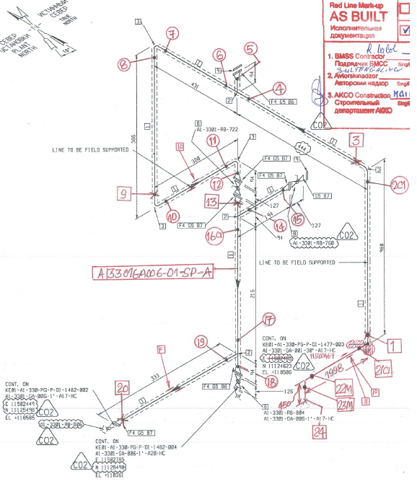
UT check spot
loc. 2
UT check spot
loc. 1
KE01-A1-330-PG-P-DI-1482-001

Inspection results
NO | LINE NUMBER | Locations | DIA(Ø), inch | Nominal thickness, mm | Extrados, mm | North, mm | South, mm | East, mm | West, mm
1 | A1-3301-GA-006-1"-A17-HC | Loc.-01  (Elbow) | 1’’ | 9.09 | 8,20 | - | - | 8,47 | 8,61
1 | A1-3301-GA-006-1"-A17-HC | Loc.-02  (Elbow) | 1’’ | 9.09 | 8.22 | 8.71 | 9.02 | - | -

Examined by:  UT L II cert. No. 735  exp. date 18.02.2022 | Name: Kabitov Nurlan | Signature: ...................... | Date: 13 Feb 2020
Approved by:  UT Level II cer. No 1A 253/15  exp date: 31.05.2020 | Name: Shakunou Andrei | Signature: ...................... | Date: 13 Feb 2020
Client Representative: | Name: | Signature: ...................... | Date: ………………

